Meeting to be held on Tuesday, 18th October 2022
at 7.30pm in the Committee Room, Wesham Community Centre.

AGENDA

APOLOGIES: Apologies from Cllr P Desmond sent to the Town Clerk

CODE OF CONDUCT AND STANDING ORDERS
Members are reminded of the standard of conduct they must adhere to during Town Council meetings.
(Updated Standards 2022 at Parish Council meetings have not yet been shared to Local Councils)

DECLARATION OF INTERESTS:
Members are reminded that any direct or indirect pecuniary or other interests should be declared as required by the Council’s Code of Conduct for Members.

22/045 APPROVAL OF THE MINUTES OF THE COUNCIL MEETING HELD
20th September 2022

22/046 MATTERS ARISING – any item not covered by agenda or action list

22/047 POLICING ISSUES
- Crime Reports – police.org.uk website > area > PR4 3DR (WCC postcode)
- Policing Issues – to discuss any items raised by Councillors

22/048 PLANNING -
- Planning Applications - FBC updating Planning system issues

22/0552 – Camping Pods, Stanley House Farm

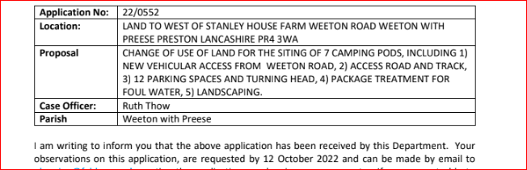

22/0732 – Extension, 34 Gartstang Road Nth

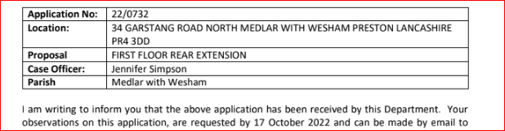

22/0724 – K&W Scout Hut

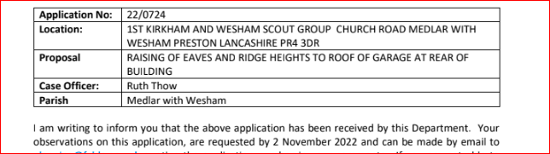

22/0616 – Employment Building @ Mill Farm...Whinfield Commercial Ltd

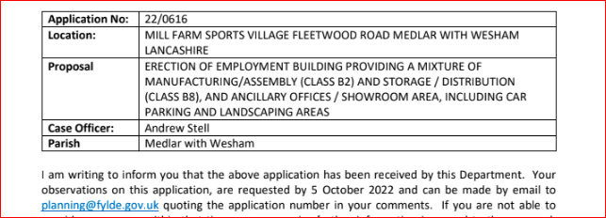

20/0135 – Car Parking , Mill Farm

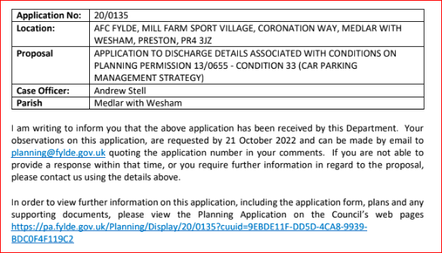

21/0984 – North Stand, Mill Farm

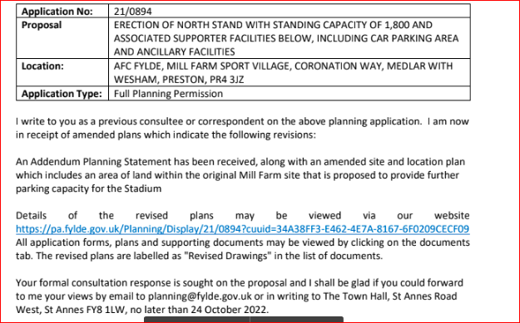

22/049 PLAYING FIELDS and OPEN SPACES
- Open Spaces Contract - to discuss any issues raised by Councillors

- Review of Grounds Maintenance
- “Deep Treatment” for Bowling Green as per Tom Ascroft quotation
- Pathways – overgrowth in Wesham areas

- Fleetwood Road Playing Fields - to discussed any issues raised

- Doorstep Green, Derby Road - to discussed any issues raised.

- Allotments – request from War veterans for an allotment

22/050 HIGHWAYS AND RAILWAYS -

21/051 GOVERNANCE, FINANCE AND INSURANCE

Accounts payable and income received report –

Finance Mtg papers - 13th October 2022

Accident and Incident Reporting - none

22/052 EVENTS
- Remembrance Service 2022 – 13th November
- Christmas Fair 2022 – 3rd December

22/053 HUMAN RESOURCES
    - WCC manager role
    - Cleaner Role
Note; These were discussed at the WCC meeting on 4th October 2022
See WCC meting notes

22/054 WESHAM COMMUNITY CENTRE
22/055 OTHER ITEMS
- Web site
- Action List – update on any items not covered by agenda

Additional items

DATE OF NEXT MEETINGS: –
Tuesday 15th November

2022 – Monthly Town Council
15th November
13th December - revised date from 20th Dec

WTC Additional Meetings
• Planning info meeting on 22/0616 application with Andrew Stell
• KJFC requested meeting – to be arranged.
• Inspection of the Allotments - 2022 (to be arranged)

Angela Hunter Date: 13th October 2022

